Program: (Bachelor/MSc) in IS  Couse ID: IS1474  Course name: User Experience  Course Instructor: Dr. Abeer Alharbi  Course Work Type:   Project  □ HW Assignment  □ Lab Assignment  *If project, Project Tile:  Streamlining the "Blackboard Student" Mobile App |  | Given Mark:  20 | *If used as a sample:  □ High  □ Medium  □ Low
 |  | Course Work includes:  □ Proposal   Report   Demonstration/ Presentation slides   Other, specify: Experiment / Evaluation  Analysis of a problems and scenarios |  Group  □ Individual
Summary of Assessed CLOs:
CLO 3.1
CLO 3.2
CLO 2.3
Group ID ( ) |  | Course Work Instructions  √ I declare that the proposed document is my own work and I own the copy right of it with no copy rights violation or plagiarism from other resources.  √ Submission due on: 31/11/2025, 11:59AM/PM  √ Cheating may cause your total mark to be ZERO grade for the whole project.  √ Only 25% of similar content is accepted from [SafeAssign] originality report.  √ The use of AI produced content is not permitted  √ -1 mark for each late day after due date, and it will not be accepted after the 3rd day.
Students Name(s) | Students IDs:
Rakan Alfadhel  Meshari Al-khanen  Omar Al-Mazrou  Abdulrahman shanar | 444003360  443015640  444004804  444002510
Rubrics |  |  | Given | Out of
Option A: Heuristic Evaluation Method
CLO 3.1 |  |  |  | 10 Marks
Task 1 |  |  |  | 5
Task 2 |  |  |  | 5
CLO 2.3 |  |  |  | 5 Marks
Task 3 |  |  |  | 3
Task 4 |  |  |  | 2
CLO 3.2 |  |  |  | 5 Marks
Task 5 |  |  |  | 5
□ Option B: User/Usability Testing Method
CLO 3.1 |  |  |  | 10 Marks
Task 1 |  |  |  | 5
Task 2 |  |  |  | 5
CLO 2.3 |  |  |  | 5 Marks
Task 3 |  |  |  | 5
CLO 3.2 |  |  |  | 5 Marks
Task 5 |  |  |  | 5
□ Plagiarized content detected. If amount is greater than % 25 total marks will be deducted by 20 Marks

□ Late submission? -1 for each day? (3 days limit)
Total Mark |  |  |  | 20
Notes:

Streamlining the "Blackboard Student" Mobile App

- App Name: Blackboard Learn

- Purpose: The mobile app for students to access their Blackboard Learn courses, view content, submit assignments, participate in discussions, and receive notifications.

Project Goal:
To redesign key features of the "Blackboard Student" mobile app to improve usability and overall student experience.

Known Issues:
- Difficult Navigation: Finding specific course content is time-consuming.

- Confusing Assignment Submission: Students struggle to submit assignments correctly.

- Poor Notification System: Students miss important announcements due to unclear notifications.

Used Method: Heuristic Evaluation Method

- Reason of using Heuristic Evaluation Method:
Heuristic​‍​‌‍​‍‌ evaluation is great and quick way to find usability issues with an interface that is not necessary to involve real users. Evaluators can check the app through the lens of recognized usability norms like user visibility, system consistency, user navigation clarity, and error prevention when using this method. It is especially a method to be used in early analysis since it shows the biggest design flaws at a low cost and with little resources. We can, therefore, use the ten Nielsen heuristics to uncover step by step the problems with the user interface of the mobile application of Blackboard that cause students to have bad experiences and low performance. As a result, they heuristic evaluation are an appropriate and efficient method to assess the current interface of ​‍​‌‍​‍‌Blackboard.
- Features to be evaluated:
  - Navigation
Navigation part of the rest covers how students navigate between courses and other areas of the app, as well as accessing content. Review of navigation is a way to establish whether information is readily accessible and the extent to which the app’s structure makes sense.
  - Assignment submission
This feature looks at how students access, upload and submit assignments. This also includes verifying deadlines, uploading files and ensuring that the submission was successful. Problems of usability in this area have the potential to impact academic success.
  - Notifications.
This includes new announcements, grades, deadlines, and announcements from the course. When done correctly, notifications are wont to be delivered timely, unambiguous so that they may not protect the user without being too overwhelming or confusing.

Nielsen Norman Group

Heuristic Evaluation Workbook
Use this workbook to conduct your own heuristic evaluation.
For each of Jakob’s 10 Usability Heuristics, look for specific places where the interface fails to adhere to the guideline. Write your recommendations for how to fix those usability issues.

Ref: https://www.nngroup.com/articles/ten-usability-heuristics/
Nielsen Norman Group
Heuristic Evaluation Workbook
Evaluator: Date: Product: Task:

Issues
On switching between sections of the course, sometimes app takes me to a black screen with no loading indication or any other hint leaving the user clueless of whether the app is still working.
1

Visibility of System Status

Recommendations
Maintain a single loading spinner or progress bar while content is being downloaded and instant confirmation messages after all major actions such as submissions or uploads.
The design should always keep users informed about what is going on, through appropriate feedback within a reasonable amount of time.
Does the design clearly communicate its state?
Is feedback presented quickly after user actions?

Recommendations
Draw on academic references such as “Assignments,” “Course Materials,” “Lectures” and/or simply, bits of knowledge.
Issues
This seems likely, given that terms like “Content,” “Items,” and “Tools” are indeterminate vocabulary terms that do not coincide with language typical of scholarly discourse and would therefore create dissonance for beginning users.
2

Match Between System and the Real World
The design should speak the users' language. Use words, phrases, and concepts familiar to the user, rather than internal jargon. Follow real-world conventions, making information appear in a natural and logical order.
Will user be familiar with the terminology used in the design?
Do the design’s controls follow real-world conventions?

3

User Control and Freedom

Issues
After a user navigates to certain pages—like submitting an assignment—they cannot return easily without closing the entire window or repeating actions, which becomes fiddly.
Recommendations
To make sure users can get out of it or go back without starting over just throw an obvious "Back"/"Cancel" button on every page.

Users often perform actions by mistake. They need a clearly marked "emergency exit" to leave the unwanted action without having to go through an extended process.
Does the design allow users to go back a step in the process?
Are exit links easily discoverable? Can users easily cancel an action? Is Undo and Redo supported?

Issues
Each course page is layed out differently, labels are not consistent. For instance, some it may be “Content” in some cases, while other instructors might have a “Course Materials” folder, and students are confused across courses.
Recommendations
Uniformize the naming, layout and iconography of all courses and sections to make them look alike to the standards of this platform (and users).

4

Consistency and Standards

Users should not have to wonder whether different words, situations, or actions mean the same thing.
Follow platform and industry conventions.
Does the design follow industry conventions?
Are visual treatments used consistently throughout the design?

5

Error Prevention

Issues
When uploading file or submitting assignments, there is no warning if the chosen file cannot be accepted for one of many reasons (unsupported format, too big, not properly attached) resulting in failed submission.
Recommendations
Pre-upload validate, alert against unsupported filetypes and too large files sizes etc. with a final confirmation to upload.

Good error messages are important, but the best designs carefully prevent problems from occurring in the first place. Either eliminate error-prone conditions, or check for them and present users with a confirmation option before they commit to the action.
Does the design prevent slips by using helpful constraints?
Does the design warn users before they perform risky actions?

6

Recognition Rather Than Recall
Minimize the user's memory load by making elements, actions, and options visible. The user should not have to remember information from one part of the interface to another. Information required to use the design (e.g. field labels or menu items) should be visible or easily retrievable when needed.

Issues
Crucial choices — like “Grades,’’ “Announcements’’ and “Assignments” — are frequently buried in sub-menus, meaning users must remember where to search each time.
Recommendations
Put commonly used features as visual quick links on the main dashboard to allow users access without having to recall multiple click paths.
Does the design keep important information visible, so that users do not have to memorize it?
Does the design offer help in-context?

7

Flexibility and Efficiency of Use

Issues
There are no shortcuts available in the app, nor personalized access to some features as all users need to follow a tedious long flow of navigation.

Recommendations
Let users pin courses they refer to regularly (e.g., “Grades,” “Assignments”) on the home screen for quicker access.
Shortcuts — hidden from novice users — may speed up the interaction
for the expert user such that the design can cater to both inexperienced and experienced users. Allow users to tailor frequent actions.
Does the design provide accelerators like keyboard shortcuts and touch gestures?
Is content and funtionality personalized or customized for individual users?

8

Aesthetic and Minimalist Design
Interfaces should not contain information that is irrelevant or rarely needed. Every extra unit of information in an interface competes with the relevant units of information and diminishes their relative visibility.

Issues
The congestion of its menus and re-used design sections make the screen feel chaotic, especially on smaller phone screens.
Recommendations
Trim the fat, streamline menu lists, and make visually similar features inseparable to produce a less cluttered interface.
Is the visual design and content focused on the essentials?
Have all distracting, unnescessary elements been removed?

9

Help Users Recognize, Diagnose, and Recover from Errors

Issues
Error messages — like failed submission or lost internet connection — are occasionally unhelpful and will pop up without telling you what went wrong, why, or how to fix it.
Recommendations
Use transparent, human-friendly error messages that tells the user what went wrong (e.g.: “Failed to upload due to weak internet”) and a way of fixing it right away (“Try again”).
Error messages should be expressed in plain language (no error codes), precisely indicate the problem, and constructively suggest a solution.
Does the design use traditional error message visuals, like bold, red text?
Does the design offer a solution that solves the error immediately?

Issues
It offers very little in-context help, and users who get hung-up at the submission process, or are unsure where to navigate must look for that information outside the app.
Recommendations
Include built-in help / search and put tips in context (e.g. very small “?” icons) alongside complicated actions such as uploading files or checking grades.

10

Help and Documentation

It’s best if the system doesn’t need any additional explanation. However, it may be necessary to provide documentation to help users understand how to complete their tasks.
Is help documentation easy to search?
Is help provided in context right at the moment when the user requires it?
Task 2: Competitive Analysis
- The chosen two similar mobile learning platforms

- The features to be evaluated
To document best practices in those similar mobile learning platforms, the feature to be evaluated across these two platforms are the following:
- Navigation
- Assignment submission
- Notifications.
 | Platform A:  App. Name: classera | Platform B:  App. Name: Madrasati
Navigation | Clean dashboard, well structured menus and courses and tools are easy to access. | Navigation is confusing, it’s hard to find some features and moving between pages is difficult.
Assignment submission | Supports online exams, automatic correction, and different types of assignments inside the app. | students submit many assignments and teachers find it difficult to sort and download them.
Notifications | Has a built‑in notification system, with updates and reminders. | No clear assignment submission notifications, so many teachers would have to use other apps (e.g. WhatsApp and Telegram) to know when students submit.

Task 3: Low-Fidelity Prototype
State the improvements in the new designed protype to address the issues identified in Task1 or To align with features in the compared platform in Task B

- Low-Fidelity Prototype
  - Homepage/Course list
  - Clear course list with readable titles.

  - A search bar at the top to quickly find courses.

  - Notification indicator showing new updates per course.

  - Simple bottom navigation for Home, Assignments, and Grades.

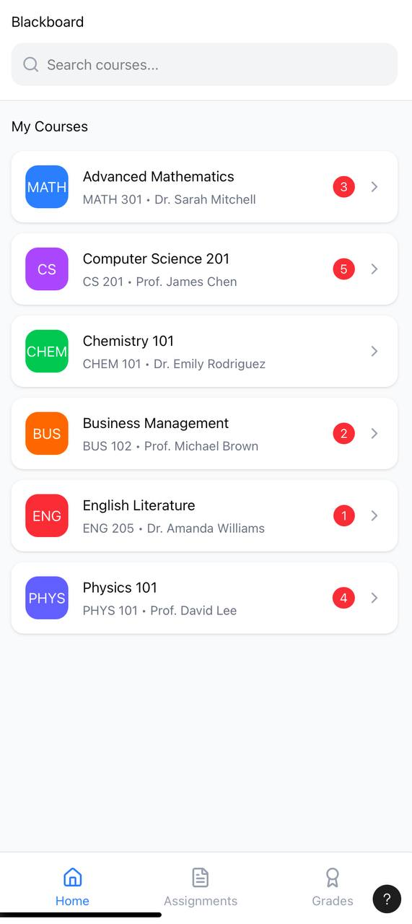

- Individual Course Page
- Organized tabs for Modules, Assignments, and Announcements.
- Clean layout with clear module progress.
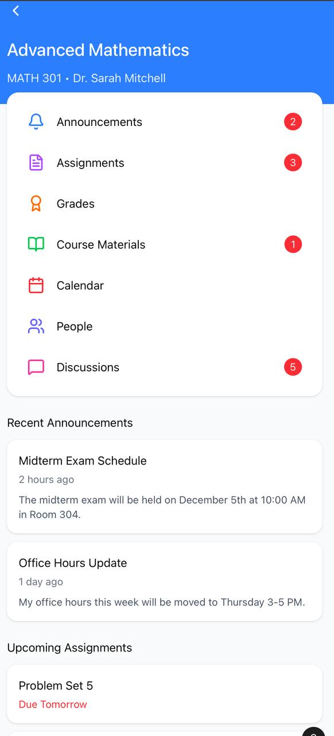

View Assignments

  - Separation between upcoming and submitted work.
  - Each assignment shows status, due date, and an accessible “Open” button.
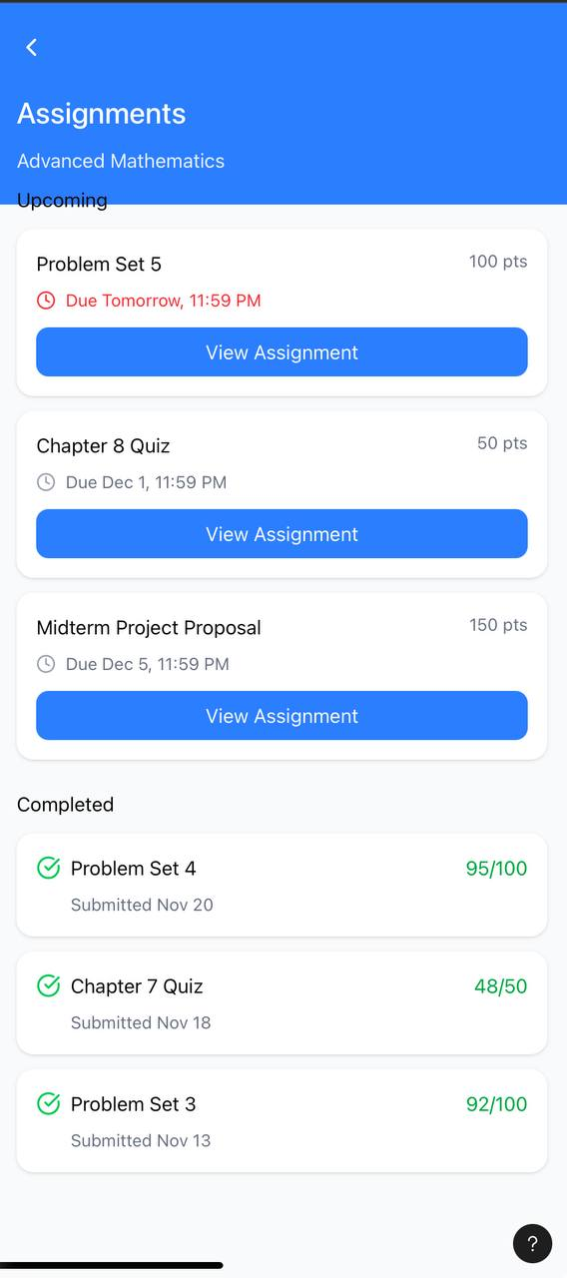

- Notification panel
- Grouping notifications by type for clarity.
- Short and direct messages.
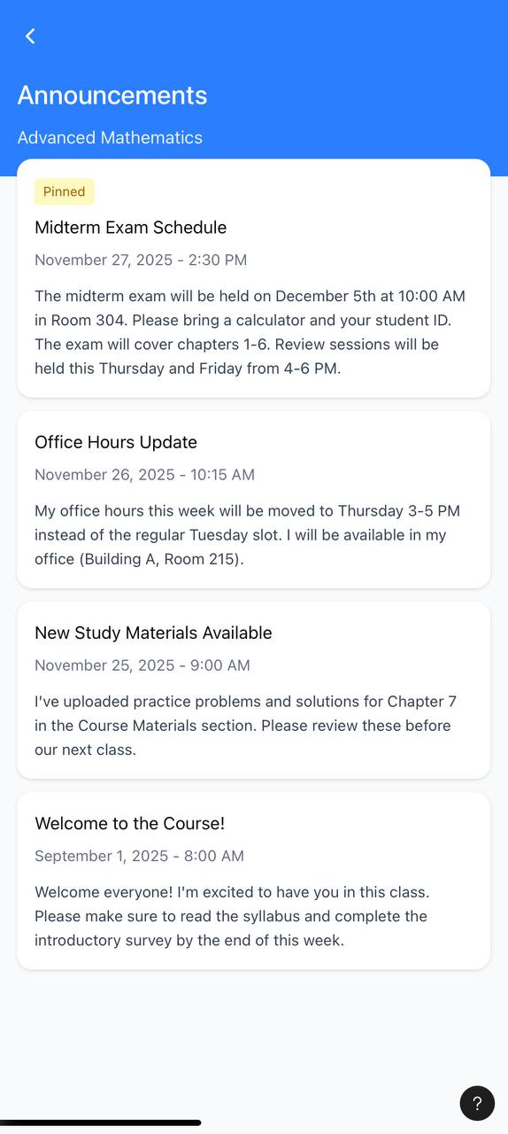

  - Grades
• Grades shown with simple progress bars.
• Total score clearly displayed.
• Option to download grade report.
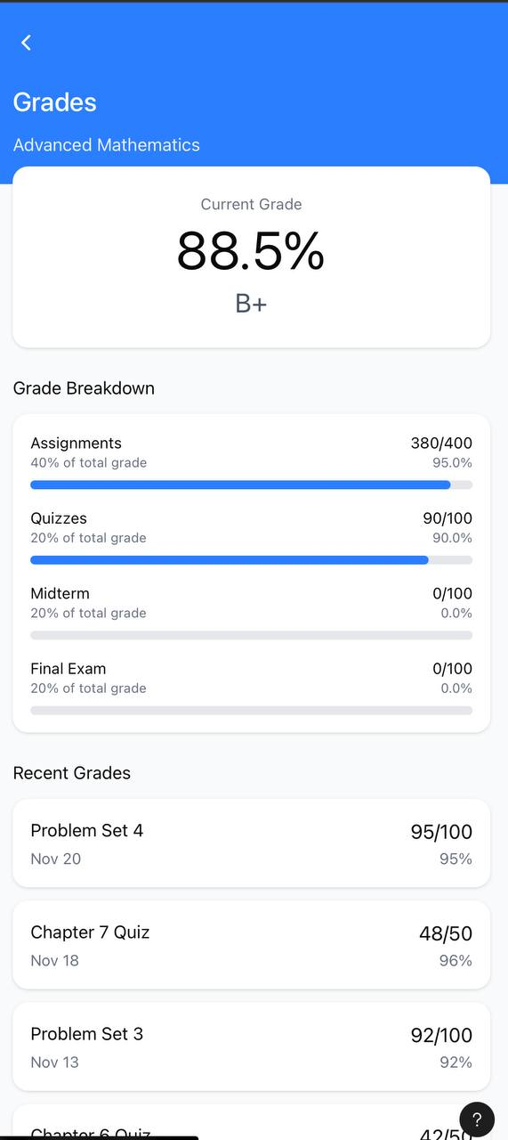

Task 4: Clickable Prototype from

Chosen function: View Assignments

Tool used: Figma

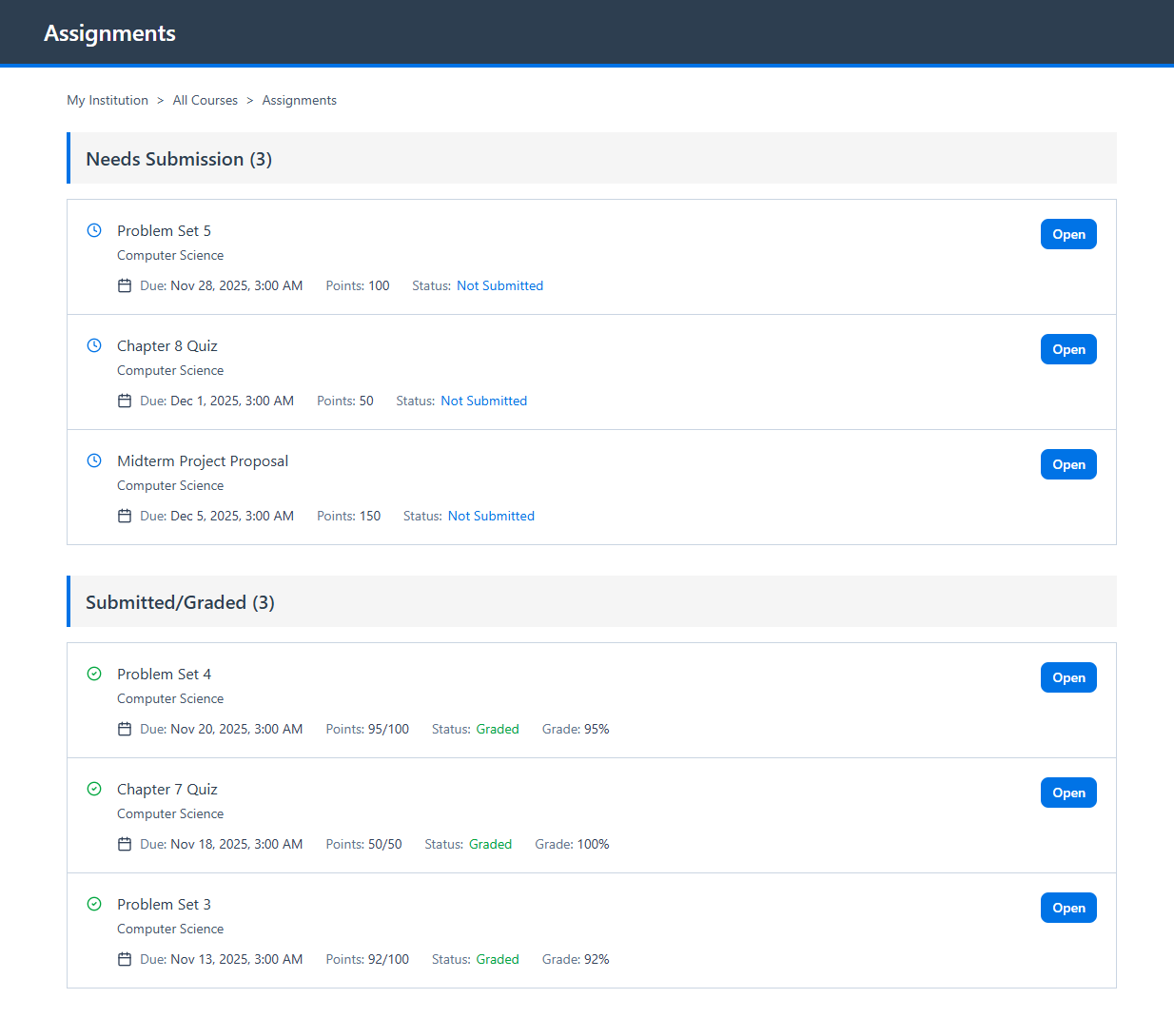

This is what it shows for not submitted assignments

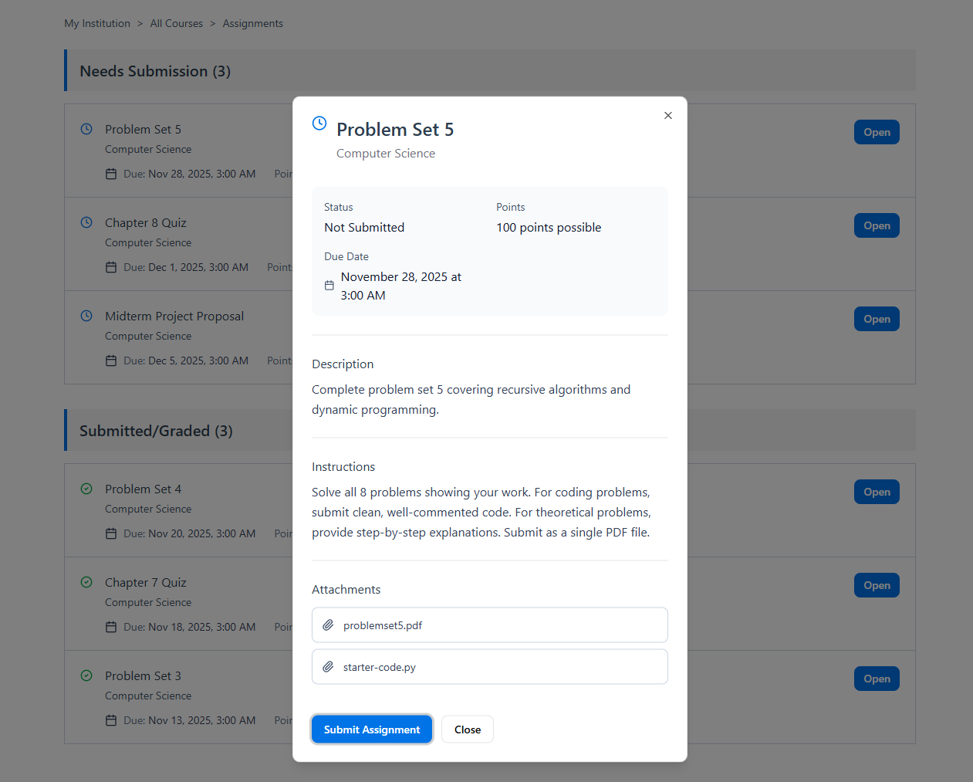

This is what it shows for submitted assignments

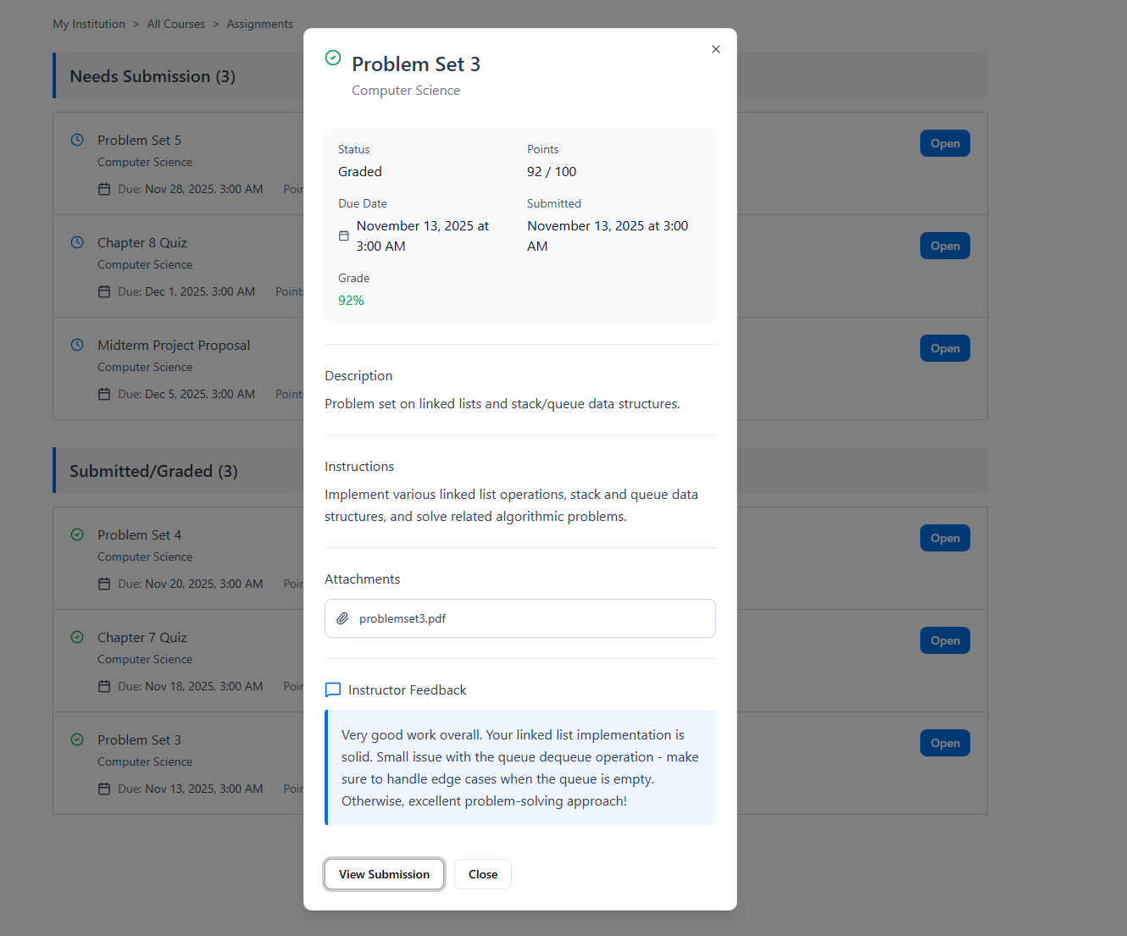

And for the whole prototype press here : Figma

Appendix (if any)
For the whole clickable prototype : https://www.figma.com/make/5IRKlQ1MTHgF3UZ7n1qtDK/View-Assignment-Interface?t=J0YAD1P69lr1qcQV-1

References
Direct links to the apps used in task2

classera
Apple App Store (iOS): https://apps.apple.com/app/id1102012717
Google Play Store (Android): https://play.google.com/store/apps/details?id=com.app.classera&pcampaignid=web_share

Madrasati
Apple App Store (iOS):
https://apps.apple.com/app/id1528970623
Google Play Store (Android): https://play.google.com/store/apps/details?id=com.t4edu.madrasatiApp&pcampaignid=web_share

